Completing the questionnaire and viewing responses to your feedback from Module Coordinators
This quick guide provides an overview of the Blue dashboard, where you will complete Module Feedback Questionnaires and view responses from Module Coordinators.

Accessing your Module Feedback Questionnaire(s)
You can access your Module Feedback Questionnaire(s) via the Blue dashboard, either directly or through the link provided in the email notifying you that Module Feedback Questionnaire(s) are open.

Completing your Module Feedback Questionnaires
- The Home page and Tasks page show your active questionnaires.
- Click Start Now next to the questionnaire you wish to complete. This opens the Welcome message.
- Click Start Now when you’re ready to begin completing the questionnaire.

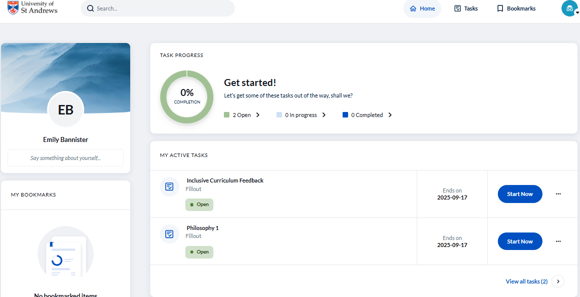

Navigating the questionnaire
- Mandatory questions are marked with a red asterisk (*) and must be completed to proceed.
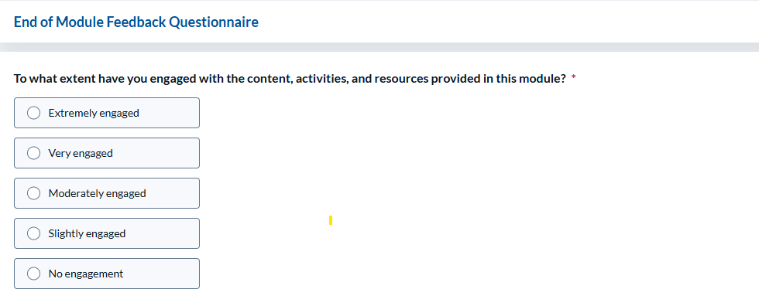
Use the following buttons to:
- Save: Exit and return later.
- Previous: Go back to review or change responses.
- Next: Move forward to the next question.

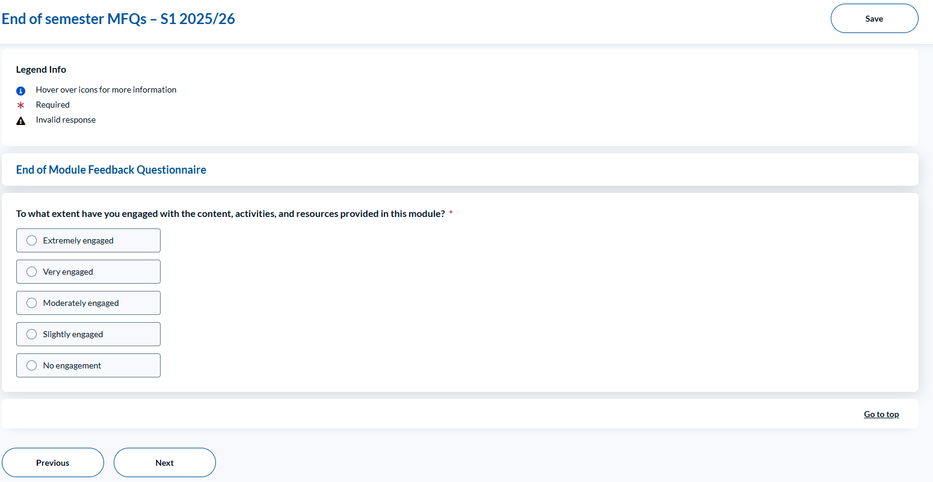

Submitting your questionnaire
- After the final question, you’ll reach a Summary page to review your responses.
- You can choose to:
  - Modify your responses
  - Save and return later or
  - Submit to complete the process.
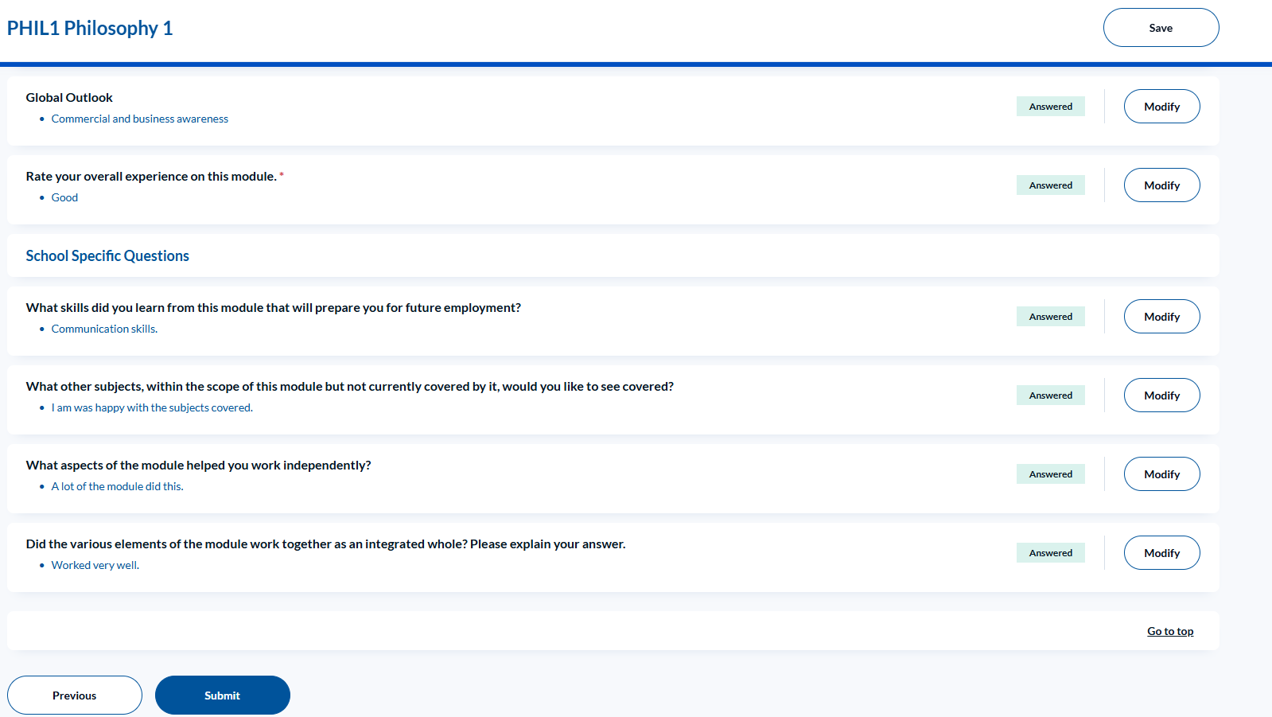

Note: if you do not submit, the questionnaire will remain marked as In Progress in your Task list. You must submit it before the closing date for completion of questionnaires.
Once submitted the questionnaire will show as Completed. Please ensure that all questionnaires are marked as Completed before the deadline.
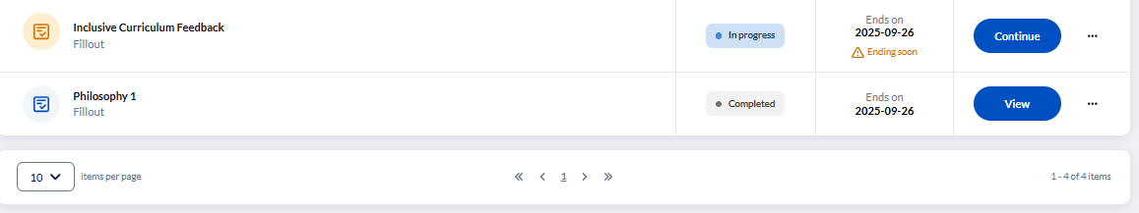

Viewing responses from Module Coordinators
After the feedback loop closes, Module Coordinators will share a summary response with students.
To view this:
- Log into the Blue dashboard.
- Go to the Home page or click Reports at the top of the page.
- Click the ellipsis (⋯) next to the relevant module.
- Select View Report or Download PDF. You can also click the PDF icon to download directly.
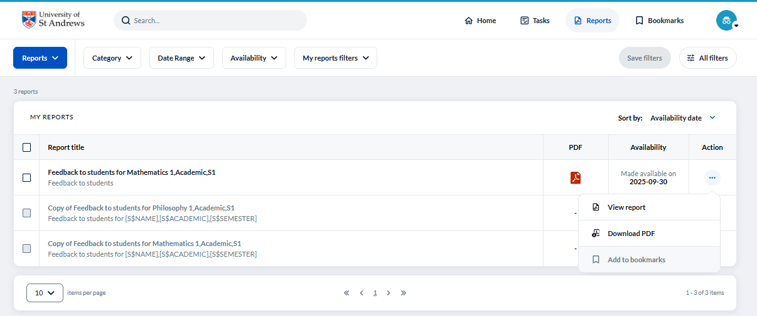
For further support, contact mfqsupport@st-andrews.ac.uk.

Completing questionnaires
Version 1 October 2025

